ASSIGNMENT NO. 5

# Name: Akshat Chandrapatle

# Div.: CSA

# Roll No: 45

# Subject: COA PRN: 12111449

**AIM :-** Write 8086 ALP to convert BCD number to its equivalent HEX number.

number.

**APPARATUS :**

* Core 2 duo/i3/i5/i7 - 64bit processor
* OS – ubuntu 32bit/64bit OS
* Assembler used –nasm (the netwide assembler)
* Editor Used – gedit

**THEORY :**

**STACK Operations:**

The stack follows the LIFO (Last In First Out) principle. The stack can be used, for example, to pass parameters to functions. T here are three instructions that can be used for interaction with the stack: Pop, Push and Exch.

**PUSH:-**

The PUSH instruction increments the stack pointer and stores the value of the specified byte operand at the internal RAM address indirectly referenced by the stack pointer. No flags are affected by this instruction.

**Operation**

**PUSH**

**SP = SP + 1**

**SP) = (direct)**

**POP:-**

The POP instruction reads a byte from the address indirectly referenced by the SP register. The value read is stored at the specified address and the stack pointer is decremented. No flags are affected by this instruction.

**Operation**

**POP**

**(direct) = (SP)**

**SP = SP – 1**

**ALGORITHM:- BCD to Hexadecimal conversion**

1. Declare

Section .data of proper string messages.

Section .bss of proper variables.

Declare various macros e.g. print, read & exit macros.

Section .text as starting point of code segment.

2. Prompt messages on screen & accept choice from user.

3. According to choice, accept 5 digit BCD no. from user using read macro. The number is

accepted in character format.

4. Point at the start of number by RSI.

5. Clear contents of RAX. Final answer will be stored in RAX.

6. Load RBX as 10 (BCD number i.e. base 10, so multiply with 10)

7. Load counter CX as 5. (5 digit no.)

8. Clear contents of RDX (for multiplication it is used. So clear previous answer)

9. Multiply RAX by 10.

i.e. RAX * RBX = RDX:RAX

previous digit * 10 = ans

10. Clear contents of RDX (for multiplication it is used. So clear previous answer)

11. Load current digit in DL from RSI.

12. Convert the contents of DL from character to digit by subtracting 30h.

13. Add the current digit in final answer.

14. Increment source pointer.

15. Repeat steps 8 to 14 till CX becomes zero.

16. Store answer from AX to ans variable.

17. Print BCD to HEX ConversiIon message on screen.

18. Store answer from ans variable to AX again.

19. Call display_16 procedure to display final 16-bit hex no. on screen.

20. Stop

**Program:**

section .data

nline db 10,10

nline_len equ $-nline

ano db 10," Assignment no :5",

db 10,"------------------------------------------------------------",

db 10," Assignment Name:Conversion From BCD to HEX Number.",

db 10,"----------------------------------------------------------",10

ano_len equ $-ano

hmsg db 10,"BCD to HEX Number"

hmsg_len equ $-hmsg

bmsg db 10,"Enter 5 digit BCD Number::"

bmsg_len equ $-bmsg

ebmsg db 10,"The Equivalent BCD Number is::"

ebmsg_len equ $-ebmsg

ehmsg db 10,"The Equivalent Hex Number is::"

ehmsg_len equ $-ehmsg

emsg db 10,"INVALID NUMBER INPUT",10

emsg_len equ $-emsg

;------------------------------------------------------------------------------

section .bss

buf resB 6

char_ans resB 4

ans resW 1

;-----------------------------------------------------------------------------

%macro Print 2

MOV RAX,1

MOV RDI,1

MOV RSI,%1

MOV RDX,%2

syscall

%endmacro

%macro Read 2

MOV RAX,0

MOV RDI,0

MOV RSI,%1

MOV RDX,%2

syscall

%endmacro

%macro Exit 0

Print nline,nline_len

MOV RAX,60

MOV RDI,0

syscall

%endmacro

;---------------------------------------------------------------

section .text

global _start

_start:

Print ano,ano_len

call BCD_HEX

Exit

;---------------------------------------------------------------

BCD_HEX:

Print bmsg,bmsg_len

Read buf,6 ;5 digit + 1 enter

mov rsi,buf ;Points at the start of buffer

xor ax,ax ;Previous digit =0

mov rbp,5 ;counter

mov rbx,10 ;multiplier

next: xor cx,cx ;contains next digit each time

mul bx ;(ax*bx)+cl

mov cl,[rsi]

sub cl,30h

add ax,cx

inc rsi ;Point at the next digit

dec rbp

jnz next

mov [ans],ax ;store ax in ans because ax get change in Print macro

Print ehmsg,ehmsg_len

mov ax,[ans]

call Disp_16 ;Print hex number

RET

;---------------------------------------------------------------

Disp_16: ;Hex to Ascii(character) display

MOV RSI,char_ans+3

MOV RCX,4 ;counter

MOV RBX,16 ;Hex no

next_digit:

XOR RDX,RDX

DIV RBX

CMP DL,9

JBE add30

ADD DL,07H

add30 :

ADD DL,30H

MOV [RSI],DL

DEC RSI

DEC RCX

JNZ next_digit

Print char_ans,4

ret

;-------------------------------------------------------------------

Accept_16: ;Ascii(character) to hex number input

Read buf,5

MOV RCX,4

MOV RSI,buf

XOR BX,BX

next_byte:

SHL BX,4

MOV AL,[RSI]

CMP AL,'0'

JB error

CMP AL,'9'

JBE sub30

CMP AL,'A'

JB error

CMP AL,'F'

JBE sub37

CMP AL,'a'

JB error

CMP AL,'f'

JBE sub57

error:

Print emsg,emsg_len

Exit

sub57: SUB AL,20H

sub37: SUB AL,07H

sub30: SUB AL,30H

ADD BX,AX

INC RSI

DEC RCX

JNZ next_byte

RET

**OUTPUT:**

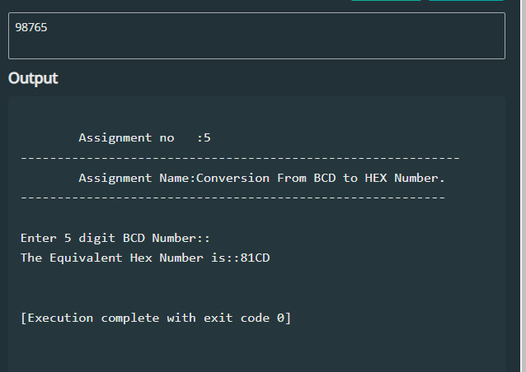

**CONCLUSION:**

To summarize, the implementation of an assembly program for converting decimal to hexadecimal was successful. The program accepts a decimal number as input, and using a loop, converts each digit to its hexadecimal equivalent and saves it in memory. The final output is displayed as a hexadecimal number.

To convert the BCD number to hexadecimal, the program reads each digit of the BCD number, multiplies it by 10, and adds the next digit to it. The result is stored in the AX register. After converting the BCD number to hexadecimal, the program calls a function to display the hexadecimal number in ASCII format.

Overall, this program demonstrates the use of several assembly language concepts, including data section, buffer, BCD to HEX conversion, macro definitions, and input/output operations.